Table of Contents

1, Download zabbix_agents_3.0.0.win.zip 0

2, Uncompress ZABBIX zip file 0

3, Enter in zabbix folder and Create a new file named zabbix_agentd.log 0

4, Enter in conf folder and edit zabbix_agentd.win.conf 0

5, copy the zabbix folder to c:\ 2

6, Install zabbix agent use cmd 3

7, Confirm zabbix agent has already been running. 5

8, Add the windows agent into zabbix monitoring 6

8.1, Setup the host name and visible name and IP. 7

8.2, select monitor template 8

9, Check the latest data. 11

# 1, Download zabbix_agents_3.0.0.win.zip

Download URL : <http://www.zabbix.com/downloads/3.0.0/zabbix_agents_3.0.0.win.zip>



# 2, Uncompress ZABBIX zip file

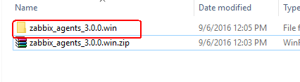

# 3, Enter in zabbix folder and Create a new file named zabbix_agentd.log

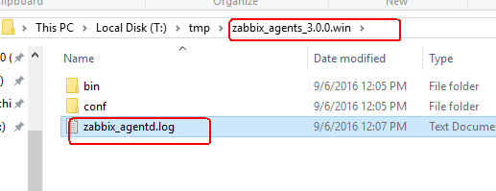

# 4, Enter in conf folder and edit zabbix_agentd.win.conf

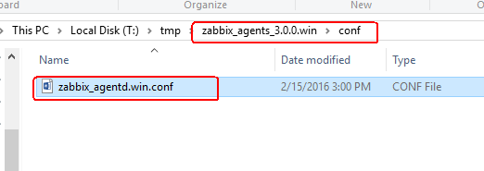

You can open zabbix_agentd.win.conf with word,

Then, modify the IP address in Server= ,modify 127.0.0.1 become your zabbix server IP.

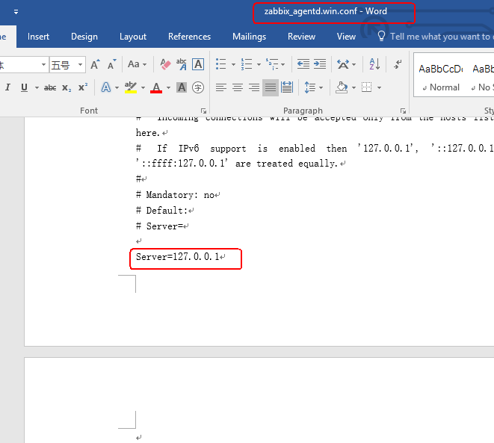

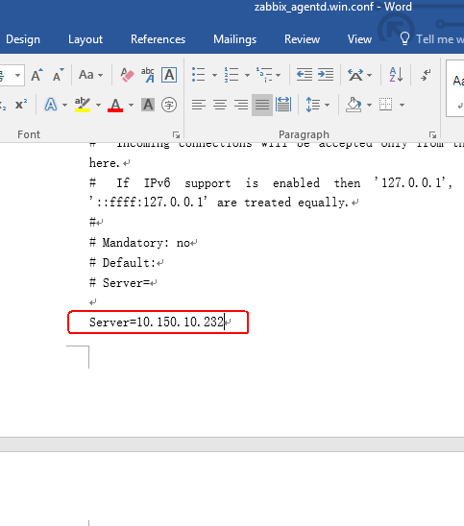

Then, save the ducoment.

# 5, copy the zabbix folder to c:\

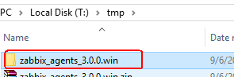

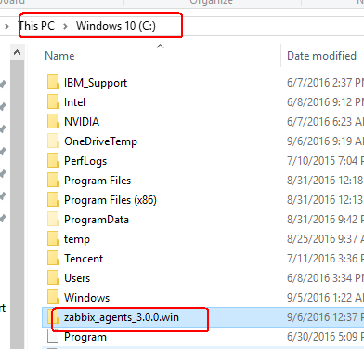

Then rename this folder to zabbix

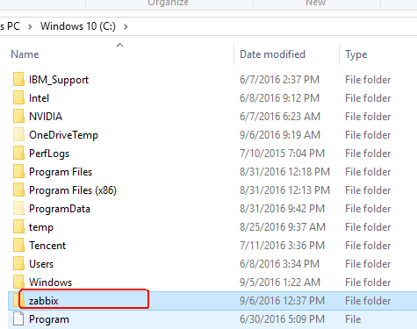

# 6, Install zabbix agent use cmd

Open cmd terminal with administrator permision

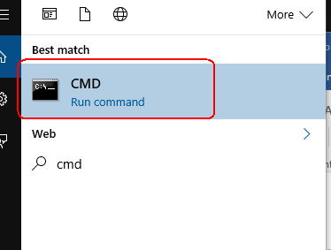

And running below commands:

cd c:\

C:\zabbix\bin\win32\zabbix_agentd.exe -c C:\zabbix\conf\zabbix_agentd.win.conf -i

C:\zabbix\bin\win32\zabbix_agentd.exe -c C:\zabbix\conf\zabbix_agentd.win.conf -s

Image as follows, now ,zabbix agent has been installed successfully, and started successfully.

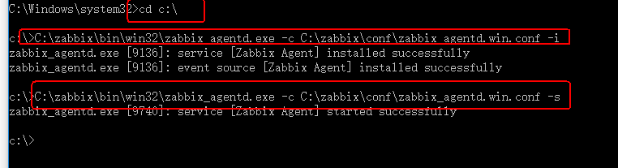

And also, you can use -h parameter to get help. As follows.

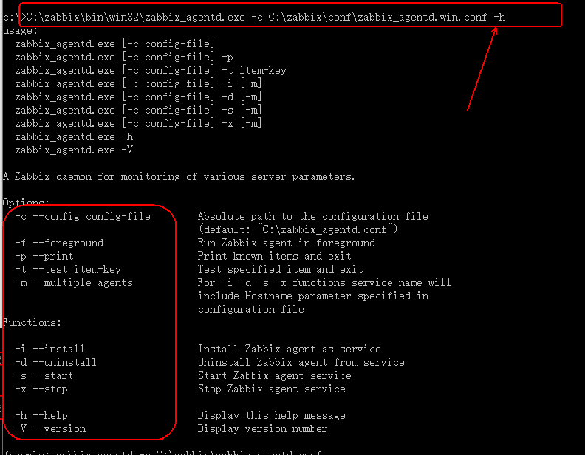

# 7, Confirm zabbix agent has already been running.

Run services.msc

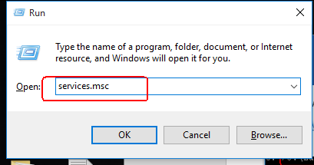

Then check the zabbix agent

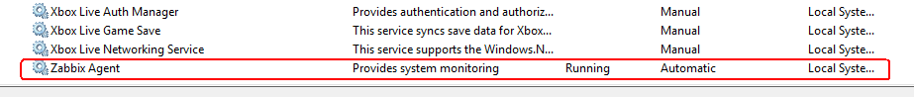

# 8, Add the windows agent into zabbix monitoring

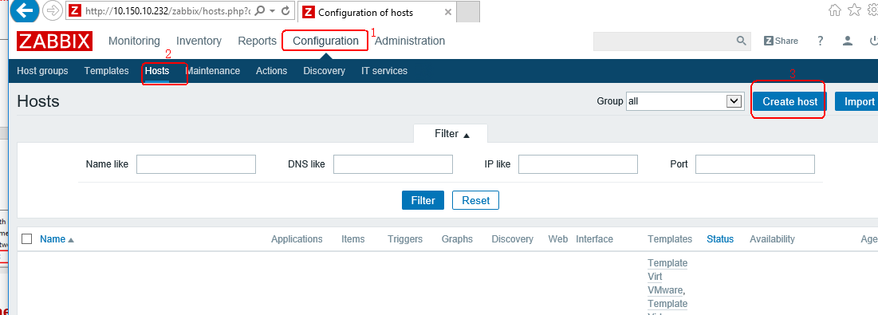

## 8.1, Setup the host name and visible name and IP.

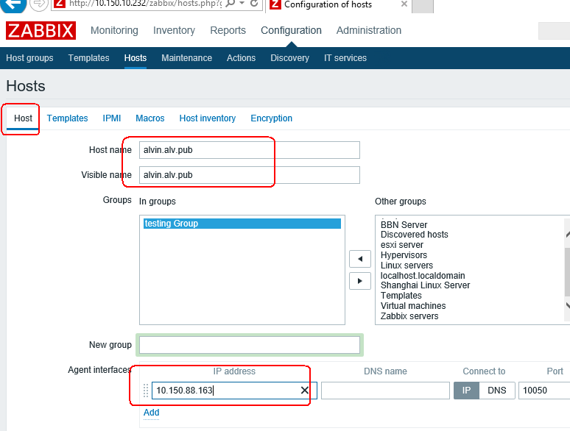

## 8.2, select monitor template

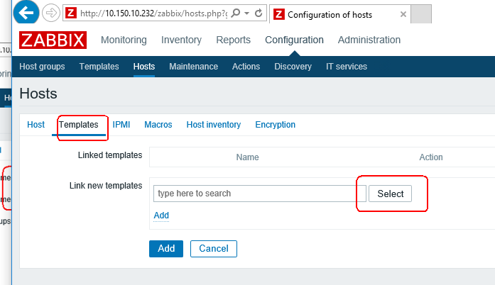



Select Templates group

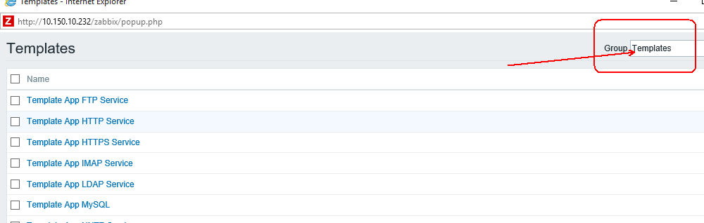

Select Template OS Windows

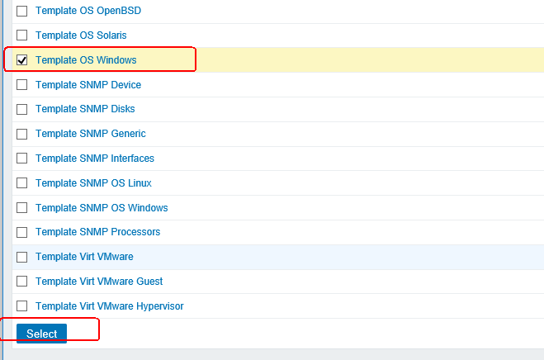

And Add,

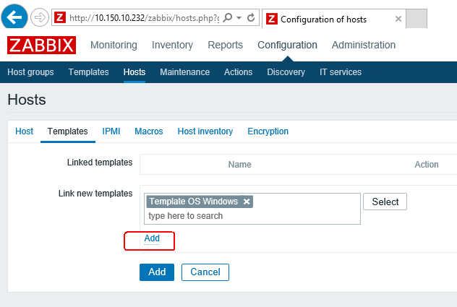

And Add

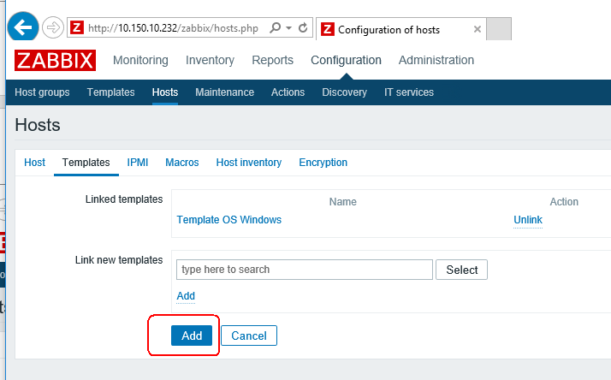

And now ,wait for monitoring. And, if your windows have setup firewall rule, then you need open the port 10050. Zabbix need to visit this port.

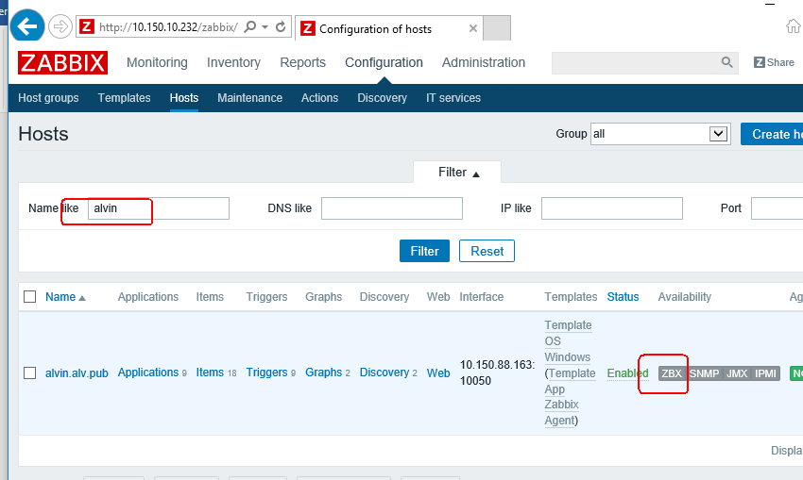

And , when waited a few minute, less than 5 minute, you will see the ZBX has changed be Green.

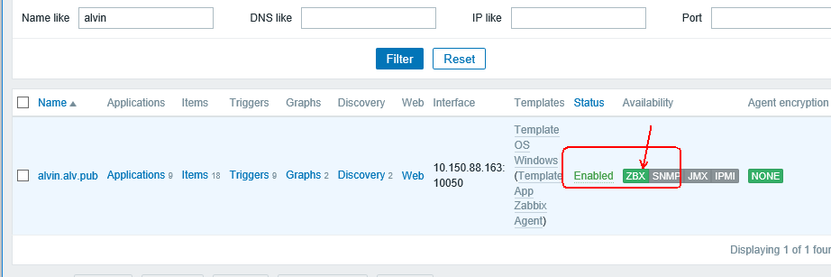

# 9, Check the latest data.

Example as follows. Some auto discovery rule will execution within an hour.